Inner Rim
# Source: AI Source: Provided by: [Data Path: Persons Table -> ID Column: 1, Name_En Column: Motasem Essam] -> From: [ChatGPT] on [7/25/2026]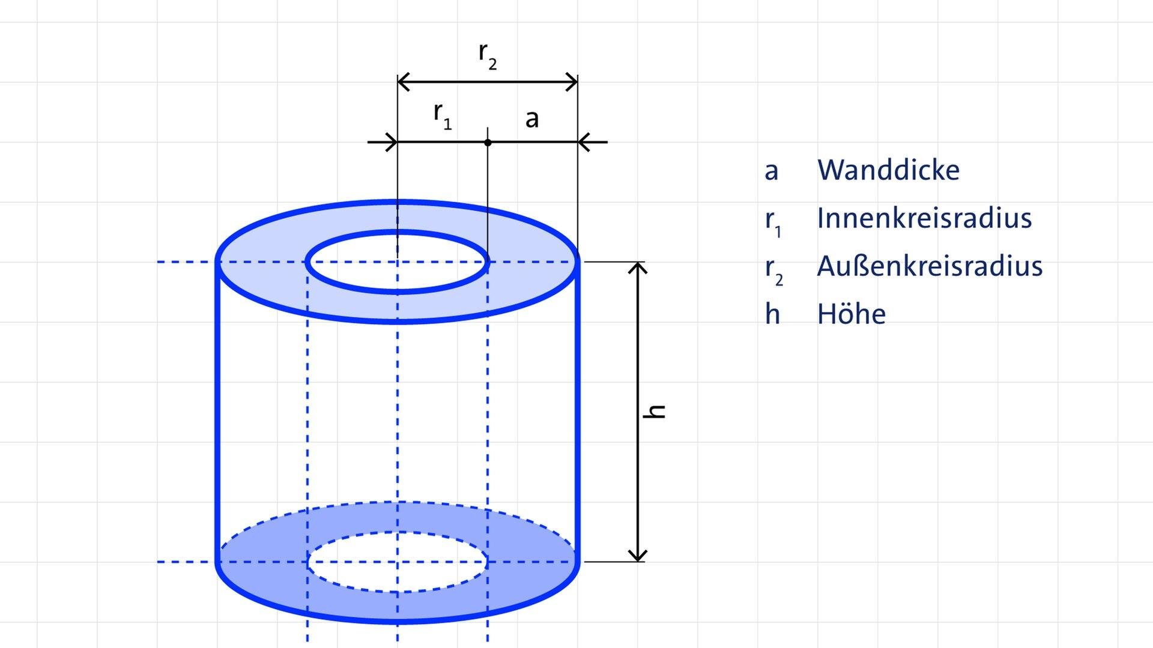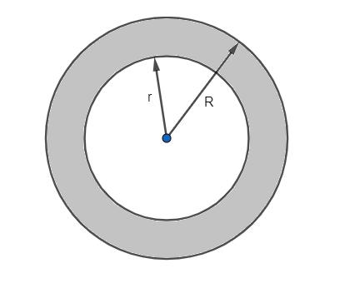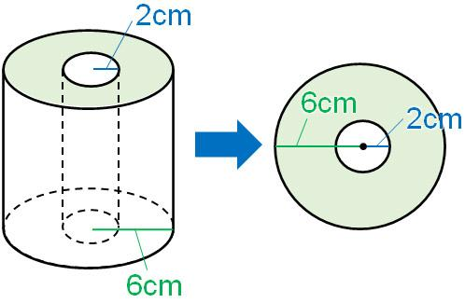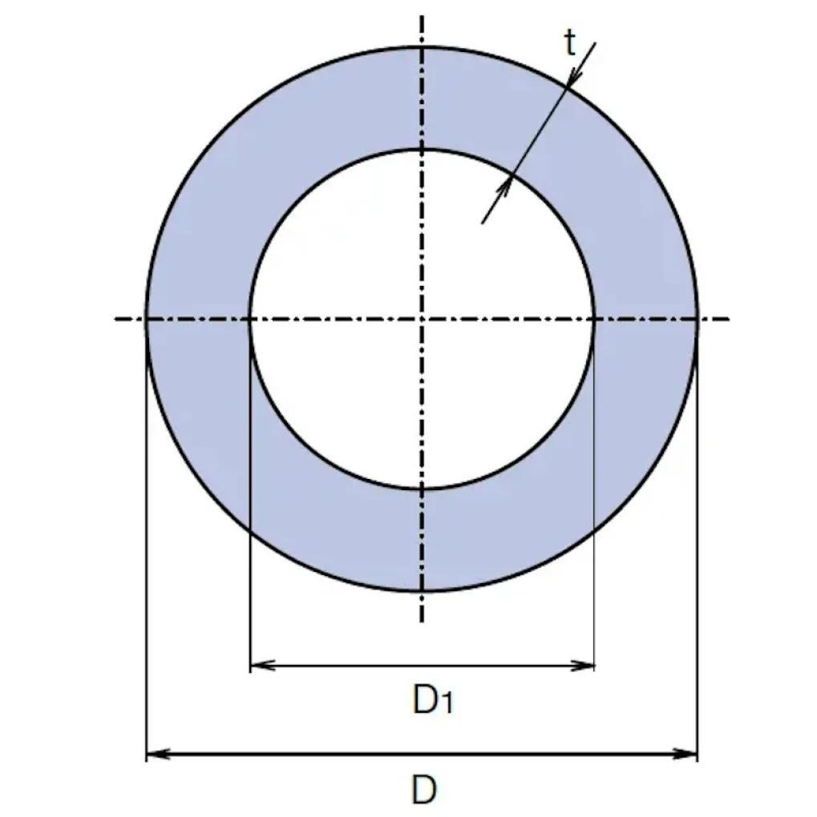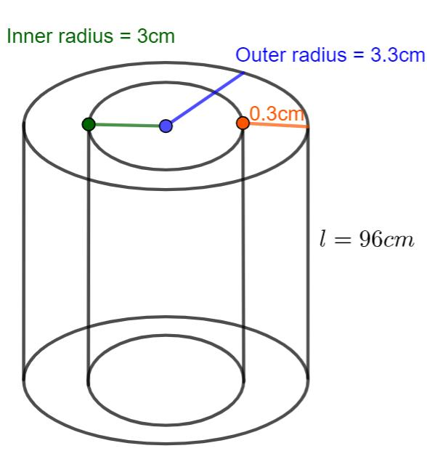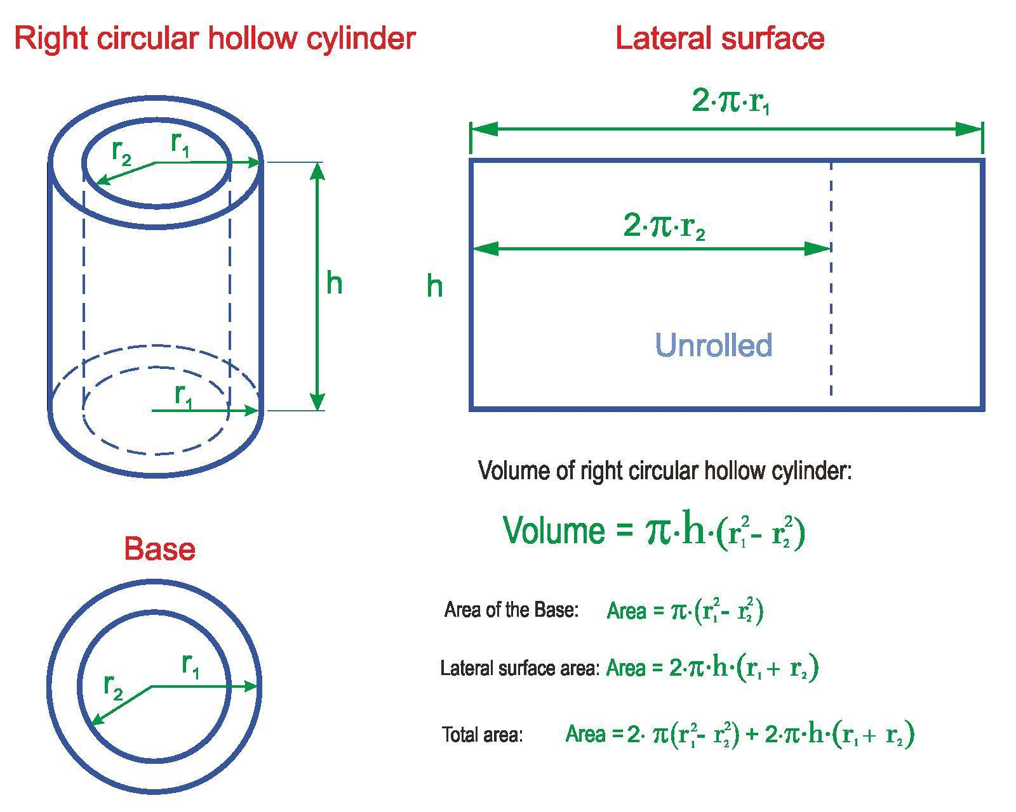

Definition
# Source: AI Source: Provided by: [Data Path: Persons Table -> ID Column: 1, Name_En Column: Motasem Essam] -> From: [ChatGPT] on [7/25/2026]
The inner rim of a hollow cylinder is the circular boundary where the inner cylindrical surface meets an annular end face.
It surrounds the hollow opening at each end of a tube or pipe. Because a hollow cylinder has an inner cylindrical surface, its annular end faces normally have both an inner rim and an outer rim.
- Position: Around the hollow opening at an end of the cylinder.
- Shape: Circular.
- Inner radius: $r$.
- Inner diameter: $D_{i}=2r$.
- Circumference: $C_{i}=2πr$.

Simple Definition
# Source: AI Source: Provided by: [Data Path: Persons Table -> ID Column: 1, Name_En Column: Motasem Essam] -> From: [ChatGPT] on [7/25/2026]
The inner rim is the circular edge around the opening inside a hollow cylinder, such as the edge around the hole at the end of a pipe.

Geometric Representation
# Source: AI Source: Provided by: [Data Path: Persons Table -> ID Column: 1, Name_En Column: Motasem Essam] -> From: [ChatGPT] on [7/25/2026]
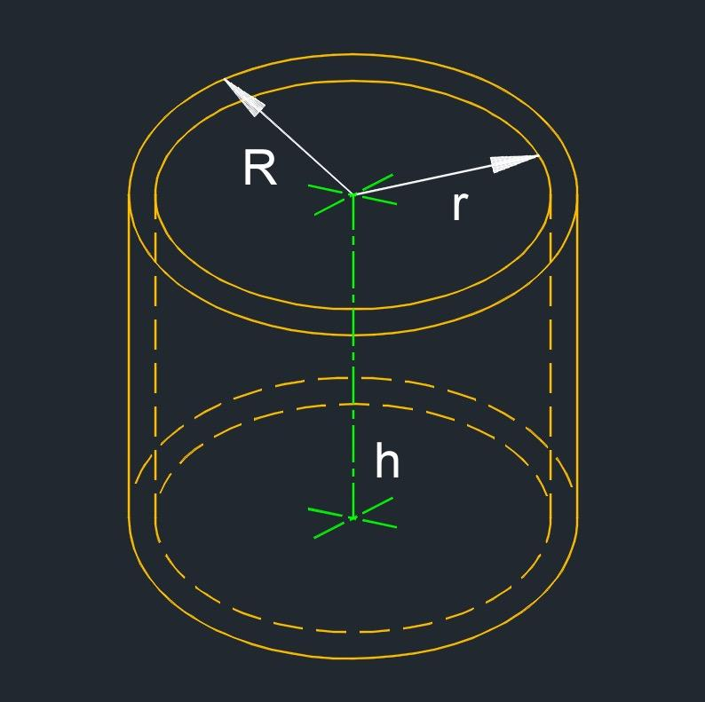
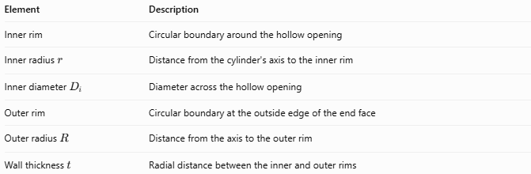
Element | Description
Inner rim | Circular boundary around the hollow opening
Inner radius $r$ | Distance from the cylinder's axis to the inner rim
$$Inner diameter{ D}_{i}$$ | Diameter across the hollow opening
Outer rim | Circular boundary at the outside edge of the end face
Outer radius $R$ | Distance from the axis to the outer rim
Wall thickness $t$ | Radial distance between the inner and outer rims
For a standard hollow circular cylinder, the inner and outer rims at each end are concentric: they share the same center and have different radii.

Types of Inner Rims

Top Inner Rim
# Source: AI Source: Provided by: [Data Path: Persons Table -> ID Column: 1, Name_En Column: Motasem Essam] -> From: [ChatGPT] on [7/25/2026]
The circular boundary surrounding the hollow opening at the upper end of the cylinder.
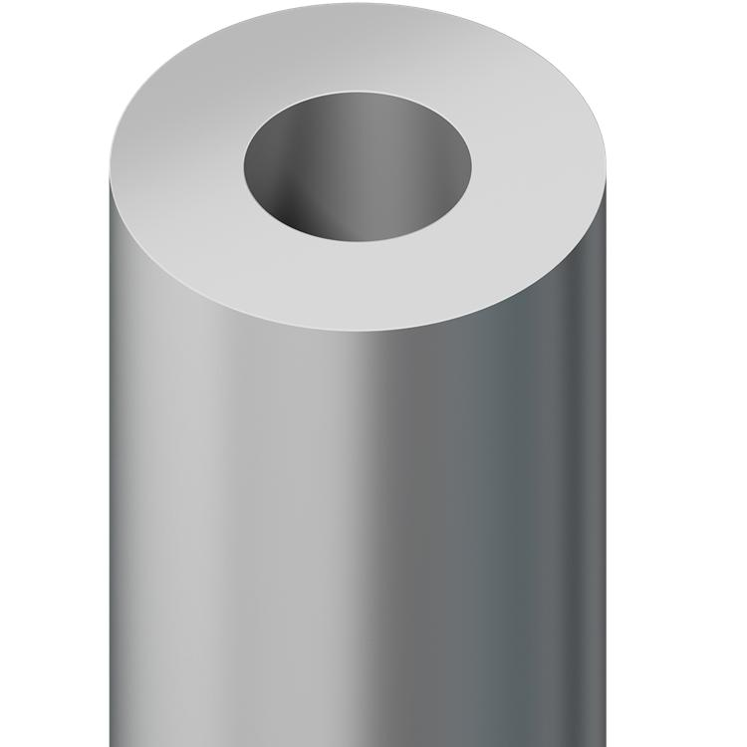

Bottom Inner Rim
# Source: AI Source: Provided by: [Data Path: Persons Table -> ID Column: 1, Name_En Column: Motasem Essam] -> From: [ChatGPT] on [7/25/2026]
The circular boundary surrounding the hollow opening at the lower end of the cylinder.
For a hollow cylinder with parallel, congruent annular ends, the top and bottom inner rims have equal radii and circumferences.
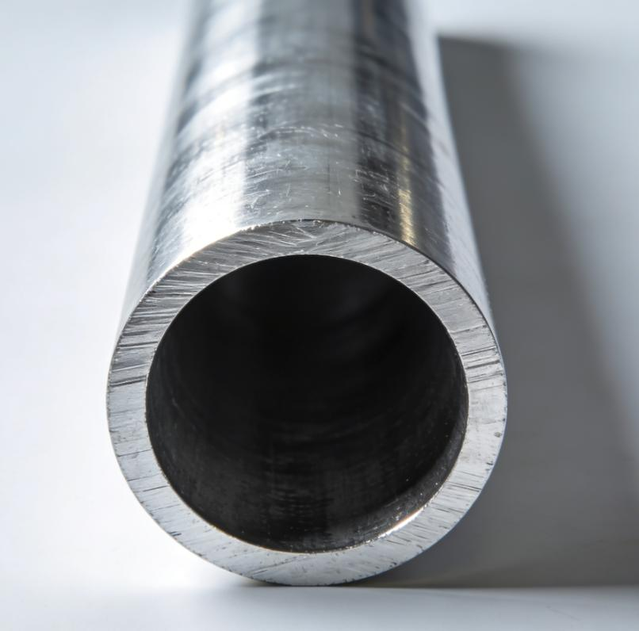

Mathematical Properties and Formulas

Inner-rim circumference
# Source: AI Source: Provided by: [Data Path: Persons Table -> ID Column: 1, Name_En Column: Motasem Essam] -> From: [ChatGPT] on [7/25/2026]
The circumference of the inner rim is:
$$\boxed{C_{i}=2πr}$$
Using the inner diameter $D_{i}=2r$:
$$\boxed{C_{i}=πD_{i}}$$

Inner radius from circumference
# Source: AI Source: Provided by: [Data Path: Persons Table -> ID Column: 1, Name_En Column: Motasem Essam] -> From: [ChatGPT] on [7/25/2026]
If the circumference is known:
$$\boxed{r=\frac{C_{i}}{2π}}$$

Inner diameter from circumference
# Source: AI Source: Provided by: [Data Path: Persons Table -> ID Column: 1, Name_En Column: Motasem Essam] -> From: [ChatGPT] on [7/25/2026]
$$\boxed{D_{i}=\frac{C_{i}}{π}}$$

Relationship to wall thickness
# Source: AI Source: Provided by: [Data Path: Persons Table -> ID Column: 1, Name_En Column: Motasem Essam] -> From: [ChatGPT] on [7/25/2026]
For a hollow cylinder, the wall thickness is the difference between the outer and inner radii:
$$\boxed{t=R-r}$$
Therefore, the inner radius can be calculated as:
$$\boxed{r=R-t}$$
The inner rim lies at radius $r$, while the outer rim lies at radius $R$.

Hollow opening area
# Source: AI Source: Provided by: [Data Path: Persons Table -> ID Column: 1, Name_En Column: Motasem Essam] -> From: [ChatGPT] on [7/25/2026]
The circular opening enclosed by the inner rim has area:
$$\boxed{A_{i}=πr^{2}}$$
This is the area of the opening, not the area of the annular end face.
The annular end-face area is:
$$\boxed{A_{annular}=π(R^{2}-r^{2})}$$

Worked Examples

Example 1 — Calculate the inner-rim circumference
# Source: AI Source: Provided by: [Data Path: Persons Table -> ID Column: 1, Name_En Column: Motasem Essam] -> From: [ChatGPT] on [7/25/2026]
A hollow cylinder has an inner radius of $4 cm$. Find the circumference of its inner rim.
Solution:
$$C_{i}=2πr$$
$$C_{i}=2π(4)$$
$$\boxed{C_{i}=8π cm≈25.13 cm}$$

Example 2 — Calculate the inner diameter
# Source: AI Source: Provided by: [Data Path: Persons Table -> ID Column: 1, Name_En Column: Motasem Essam] -> From: [ChatGPT] on [7/25/2026]
The inner rim of a pipe has a circumference of $16π mm$. Find the inner diameter.
Solution:
$$D_{i}=\frac{C_{i}}{π}$$
$$D_{i}=\frac{16π}{π}$$
$$\boxed{D_{i}=16 mm}$$

Example 3 — Calculate the inner radius and wall thickness
# Source: AI Source: Provided by: [Data Path: Persons Table -> ID Column: 1, Name_En Column: Motasem Essam] -> From: [ChatGPT] on [7/25/2026]
A hollow cylinder has an outer radius of $8 cm$ and a wall thickness of $2 cm$. Find the inner radius and inner-rim circumference.
Solution:
First, calculate the inner radius:
$$r=R-t$$
$$r=8-2=6 cm$$
Then calculate the circumference:
$$C_{i}=2πr=2π(6)$$
$$\boxed{r=6 cm}$$
$$\boxed{C_{i}=12π cm≈37.70 cm}$$

Comparison with Related Concepts
# Source: AI Source: Provided by: [Data Path: Persons Table -> ID Column: 1, Name_En Column: Motasem Essam] -> From: [ChatGPT] on [7/25/2026]
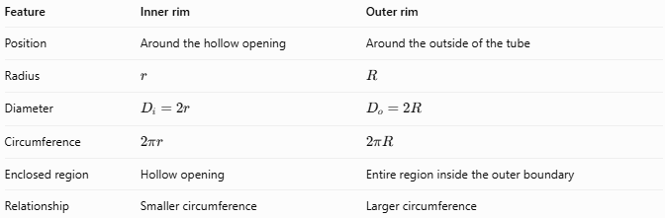
Feature | Inner rim | Outer rim
Position | Around the hollow opening | Around the outside of the tube
Radius | $$r$$ | $$R$$
Diameter | $$D_{i}=2r$$ | $$D_{o}=2R$$
Circumference | $$2πr$$ | $$2πR$$
Enclosed region | Hollow opening | Entire region inside the outer boundary
Relationship | Smaller circumference | Larger circumference
For a hollow cylinder with positive wall thickness:
$$R>r$$
Therefore:
$$C_{o}>C_{i}$$

Applications
# Source: AI Source: Provided by: [Data Path: Persons Table -> ID Column: 1, Name_En Column: Motasem Essam] -> From: [ChatGPT] on [7/25/2026]
The inner rim is useful in:
- Measuring the opening of pipes and tubes.
- Specifying the inner diameter of cylindrical fittings.
- Designing connectors, sleeves, and hollow shafts.
- Determining the cross-sectional area of a pipe's opening.
- Calculating the material area at the ends of hollow cylindrical components.

Key Points
# Source: AI Source: Provided by: [Data Path: Persons Table -> ID Column: 1, Name_En Column: Motasem Essam] -> From: [ChatGPT] on [7/25/2026]
- The inner rim is the circular boundary around a hollow cylinder's opening.
- Its radius is the inner radius $r$.
- Its circumference is $C_{i}=2πr=πD_{i}$.
- A hollow cylinder normally has a top inner rim and a bottom inner rim.
- The inner rim is distinct from the outer rim and the annular end face.
- Wall thickness is $t=R-r$.

Conclusion
# Source: AI Source: Provided by: [Data Path: Persons Table -> ID Column: 1, Name_En Column: Motasem Essam] -> From: [ChatGPT] on [7/25/2026]
The inner rim is the circular boundary where a hollow cylinder's inner cylindrical surface meets an annular end face. It defines the edge of the hollow opening and is measured using its inner radius, inner diameter, and circumference.

